March 22, 2013
Ankun Fang

This Week:

This week was spent implementing the most important features into our main program GUI, which is the HTML, and making sure they work properly. Connor spent the majority time creating a timing system, and character classes. I spent most of the time creating a movable monster towards the player that enlarges as you answer the question incorrectly every time you click a button.
There are still some issues such as getting a batSpam function working to allow a bat flying on the screen. We got the main screen working relatively well for now, and the math game has been implemented, and works with the main screen.
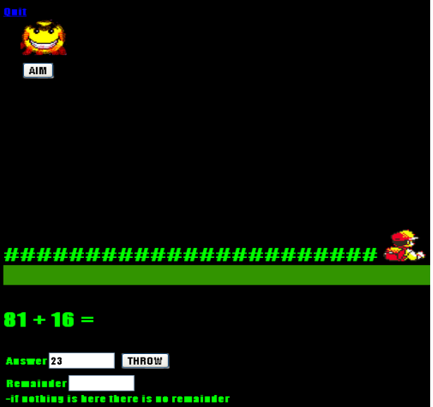
Here is what it looks like:
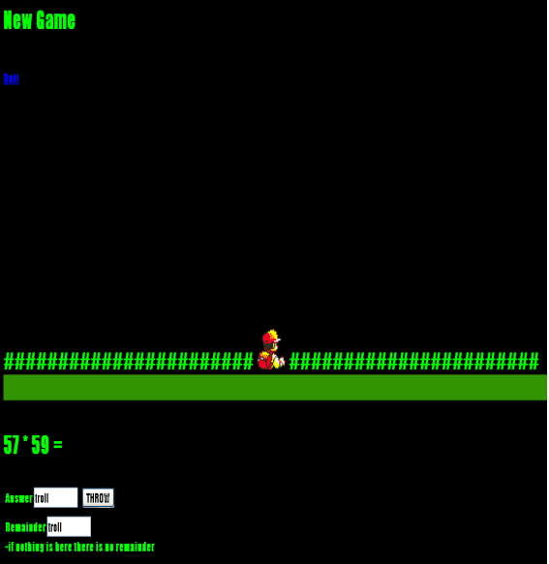
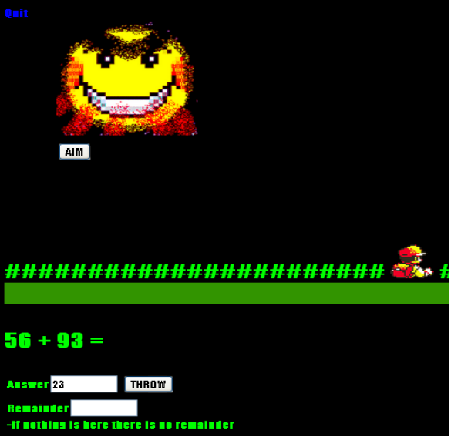
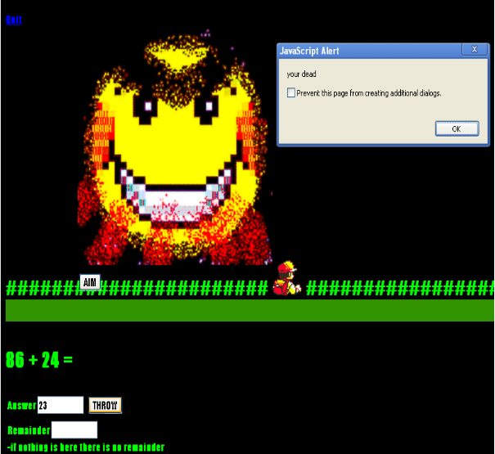

Next week:

Next week we are going to solve the issue of copying the classes into another array. Connor is going to excess my files again and fix some errors, and I will do the same. I need to be able to implement the timing function properly and add more monsters into the game. We need to have a function that calculates the distance between the monster and the player, in order to calculate how much pixels the monster needs to go down every turn, because all monster images are different.
If we can this, then the majority of our development will be solved. We need to modify some code to fit our main program. We also need to start implementing the pictures into our code.
We will be waiting for the kid's pictures.

